**Walnut Wood Floating Shelves**

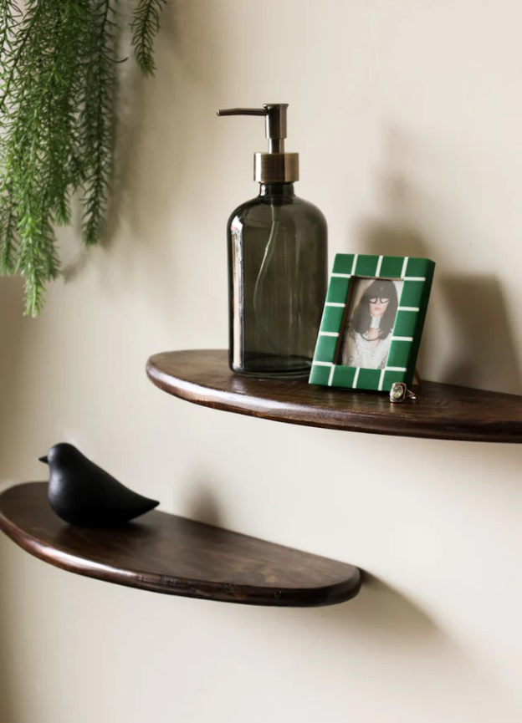 Walnut wood floating shelves bring a touch of natural elegance and timeless sophistication to any room. Crafted from rich, warm-toned walnut, these shelves feature a sleek, minimalist design that highlights the beauty of the wood grain. Perfect for displaying books, art pieces, or decorative items, they provide functional storage while adding a luxurious feel to your space. Their versatile design complements various interior styles, from modern and mid-century to rustic, making them a stylish and practical addition to any home.